Open template through cmd

Install quasar

install node

install python

install quasar->

$ npm i -g @quasar/cli

$ npm init quasar

Move inside folder cd …

cd projectname

Run app in browser

quasar dev

Run app for desktop (electron)

quasar dev -m electron

**Run python code with frontend ->command**

npm run dev:be

Vue.js🡪 build using🡪 TEMPLATE+Scripts+Style

**Postgress DB Integration:**

Src-electron>database

1. Config.js: Change postgress credentials

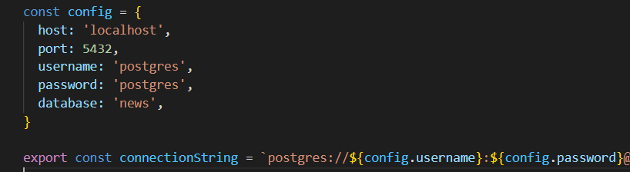

1. Models>users.js: [write code to create the table] 🡪you can create directly using pgadmin4
2. Index.js :

uncomment and run only First time-> user.js[create table] ->database

// sequelize.sync(

    //   { force: true }

    // );

1. Pages>login.vu

uncomment and run only First time->

// API("auth.createUser", { username: "sample", password: "123", role: "user" });

**--------------------------------------------------------------------------------**

**how pass data from python to Controller using Socket**

python->(node)controller->frontend

(node)controller->frontend

**backend Node**

client listen on “numbers” url -> actually gives path

    client.on("numbers", (data) => {

      console.log({

        data

      })

      resolve(data);

    })

if data receive, Then emit (emit means get data from python)

client.emit("getNumbers");

then

export default {

  getUserNames,

  getNumbers

}

**backend Python**

@sio.event

def getNumbers():

    numbers = []

    for i in range(30):

        numbers.append(i)

    sio.emit("numbers", numbers)

**------------------------------------------------------------------------------**

**How creates Controller in node**

Controller unable us to transfer data from backend to frontend

1. Go to src-controlers>controllers
2. Create page2_controler.js

And write inside page2_controler.js

const getUserNames = ({ token, name }) => {

  console.log(token, name)

  return ["john", "cena", "batista"];

}

export default {

  getUserNames

}

1. Go to controlers>index.js and import

import home from './homeController';

and give it’s name ->home

const controllers = {

  auth,

  home

};

---------------------------------------------------------------

How Call Method in page.vu

As Vu.js file build using🡪 TEMPLATE+Scripts+Style

<template>

</template>

<script>

  mounted() {

    API('home.getNumbers', {}).then(res => {

      console.log(res);

    })

  }

</script>

**---------------------------------------------------------------------------------**

**How add page and define rout**

1. Add page

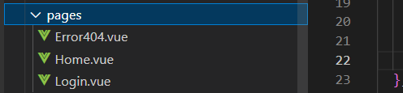

1. Define rout for this page

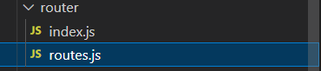

1. Import page

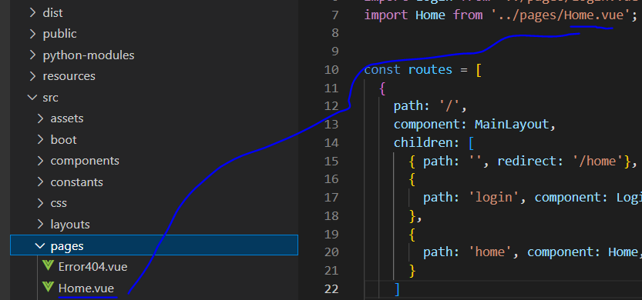

1. Add rout name against page

